Hamzah baig

Gym Website

Computer Science NEA

Contents

0

Analysis 2

Problem 2

Research 2

Alternate solutions 2

Existing solution 3

Questionnaire 3

Interview 4

Requirements 5

Objectives 5

Modelling Diagrams 5

Entity-relationship diagram 5

Design 6

Entity-Relationship diagrams 6

Flowchart algorithms 6

Pseudocode 6

Graph diagram 7

References 8

# Analysis

## Problem

A local gym has not had lots of members joining the gym. They are worried that they are not going to be in business for much longer and have decided to try and get more members to join the gym. They realise that most things nowadays are done online and that it is far more convenient to sign up online than come all the way to the gym to sign up. As a result, the gym would like a website that where people can sign up to the gym, book classes, and see alerts and announcements from the gym.

This main age group this website would benefit from is ages 18 to around 40 as they are more comfortable signing up online. Older people may prefer to speak face to face to someone and they feel less comfortable about giving their money to a computer screen. Staff at the gym will also benefit from this as they will have to deal with less people and have more time to do other things around the gym.

## Research

### Alternate solutions

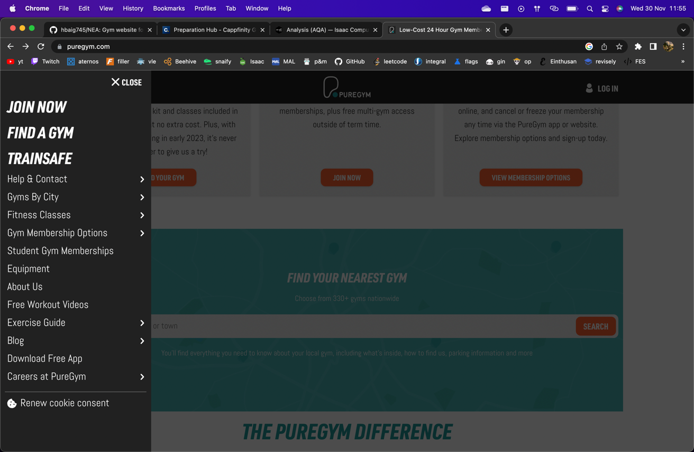

This is the PureGym website. Good features from this website that would be good to include into our new system would be the easy navigation. The navigation bar is easily accessible and is easy to find your way through the website. ‘Find a gym’ is a useful function for this website along with ‘Join now’. Our system should allow users to be able to register for the gym. The ‘Fitness classes’ section is also something that we are hoping to incorporate into our website. Something that we are inspired from this website that we also have decided to add is the ‘Workout videos’ as we’ve decided that it’s a good feature to have for your website.

### Existing solution

The existing way that people have to sign up to the gym is by coming to the gyms reception and signing up there and same goes for booking classes. What is good about this system is that all the members information is stored into a database and they are able to pay for the membership then and there. Members like this existing system as they are reassured and have human confirmation that all transactions and information is correct and that everything has happened smoothly. However, what is not good about this system is that it could be annoying and time consuming for some people. Members do not like this system as it takes a longer time to complete and often requires extra effort and time that may not be available to them. Some members also dislike talking to someone else and them relying on someone else and would prefer to just do it themselves.

My solutions will keep these positives as users can still register and verify their information that they inputted and it will all be stored in a database. An email confirmation system will also be implemented so that users can have confirmation of payments and registry. What my system will improve on is that it will allow users to register online and make all payments online. This will solve the problem of members not wanting to waste time coming into the gym as everything can be done online. This will also benefit the users who would prefer no social interaction as there is only interaction between the user and the computer.

### Questionnaire

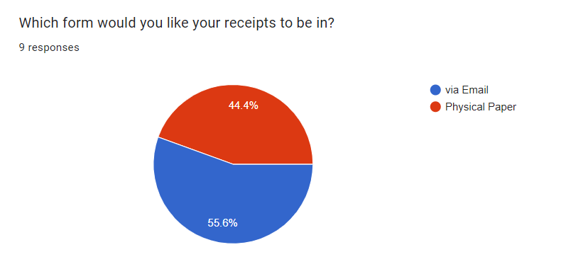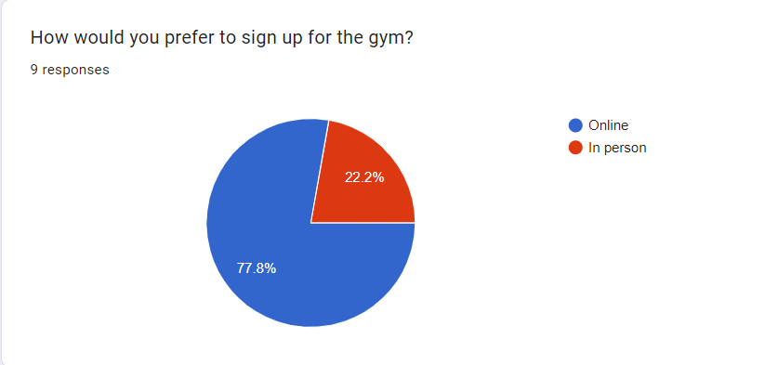

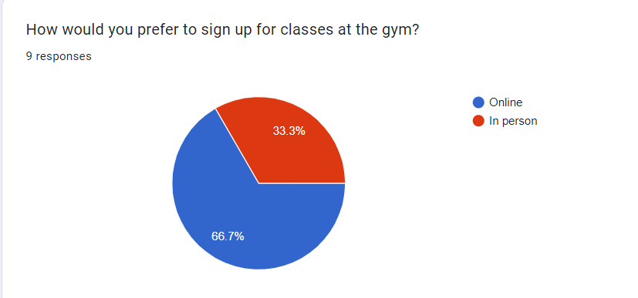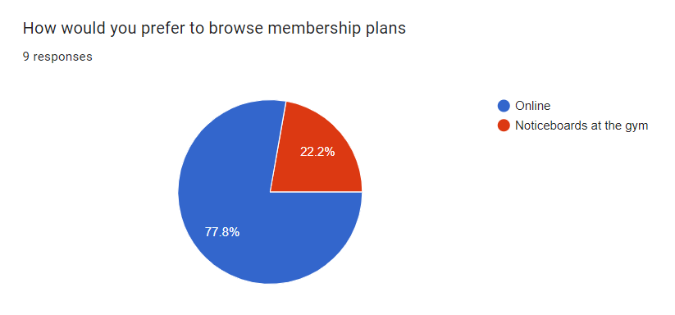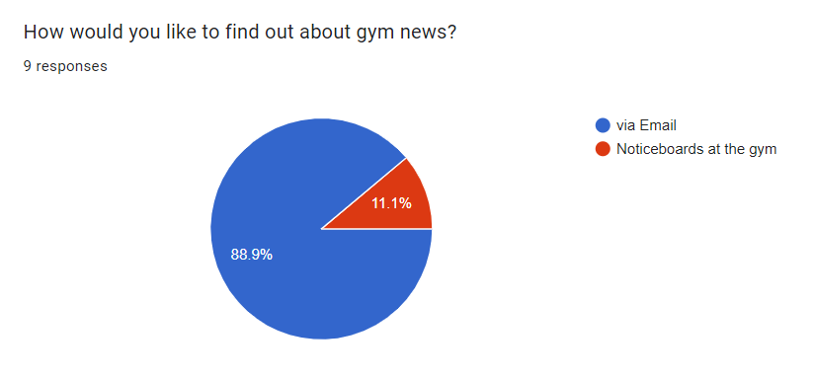

This questionnaire proves that people would prefer to have most things done digitally and online. There are still people who prefer to do things the old-fashioned way and the old system will therefore still be in place and functional and the new system will just build upon what is already used and won’t replace it entirely as there is minority of target audience who would still use it, therefore not entirely useless.

### Interview

Johnathan smith, owner of the gym, interviewed about how he would like the new system to function.

“Would you prefer receiving memberships online or in person?”

*I would prefer people to pay using direct debits or card as cash is easily lost and stolen whereas we have a good finance team and good cybersecurity so money in the bank accounts would not be lost. However, we would still like people to be able to pay in cash so we don’t lose clients/customers but would encourage people to set up a direct debit.*

* Have a direct debit set up for members
* Keep current system for members who don’t want to switch

“Do members have access to different gyms around the country?”

*Yes, members have access to all our gyms. It would be good for people to find the gym closest to them as our branches sometimes are closed for maintenance and therefore would like members to be able to find the gym closest to them that isn’t shut down.*

* Abstracted map to show other branches
* Shortest path algorithm to find closest one.

“How would you like members to sign up to classes?”

*I would like this to be like how they sign up. If they would like to do it in person, then the option is available to them however we would encourage people to do it online. This booking would then be stored in a database that maps the user to the class they’ve booked.*

* Integrate old system into the new one
* Store the information in databases

“Would you like to have workout videos on the website?”

*It wasn’t something I was planning on having however I think it would be a beneficial addition to the website. Having videos may inspire people to join the gym, therefore we gain more clients/customers.*

* Display YouTube fitness videos on the website

“What colour scheme would you like the website to have?”

*I quite like the colour palette for the PureGym website. I would prefer a lighter black as the main colour with cyan/blue accents. Maybe some dark grey as well?*

* Colour scheme of lighter black, cyan, blue and grey.

## Requirements

System requirements:

* Have direct debits set up for the members
* Integrate old system so that it can still be in use and work in parallel
* Allow members to find their closest open gym
* Store user info in databases
* Have a page to display YouTube videos
* Black, grey and cyan colour scheme

## Objectives

1. Initialise React packages and create the project
2. Set up different parts of web app and build the html for each part of the website
   1. Navigation bar
   2. Main text
   3. Login pop up
3. Implement the data structures and algorithms
   1. Dijkstra’s algorithm
      1. Graph
      2. Breadth first search
4. Connect to the backend with flask
5. Create the REST API for the backend and create the databases
6. Make the website look nice with CSS
7. Add cool looking animations

These objectives are to be completed by the due date of 15th May.

## Modelling Diagrams

### Entity-relationship diagram

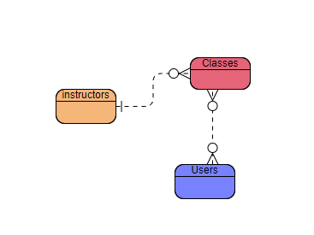

*Abstracted version of entity-class diagram*

# Design

## Entity-Relationship diagrams

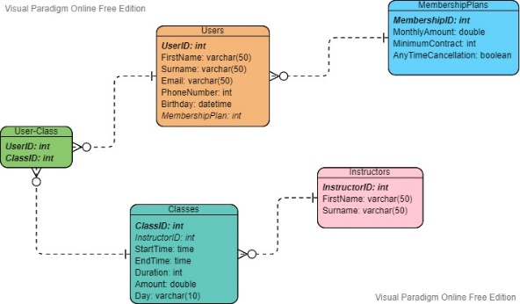

*Diagram to show the relationships, attributes, primary and foreign keys of all entities included in systems relational database system.*

## Flowchart algorithms

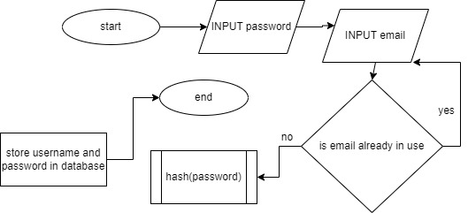

*^^ Flowchart to show how users will be signing up*

## Pseudocode

Declare the visited list

Declare the unvisited list

For each node in the graph:

Add node to the unvisited list with distance of infinity and previous node of null

Set the start node's distance to 0 in the unvisited list

While the unvisited list is not empty:

Set current node to the node with the lowest cost from the unvisited list

Copy cost and previous values for current node from the unvisited list to the visited list

Remove the current node from the unvisited list

For each neighbour of current node:

If neighbour node is not in the visited list:

Calculate new cost = weight of edge + cost of current node

If new cost is less than neighbour node's cost in unvisited list:

Update the neighbour's cost to become the new cost

Update the neighbour's previous node to become the current node

Return the visited list

Pseudocode for Dijkstra’s algorithm from Isaac computer science

(Isaac computer science, n.d.)

## Graph diagram

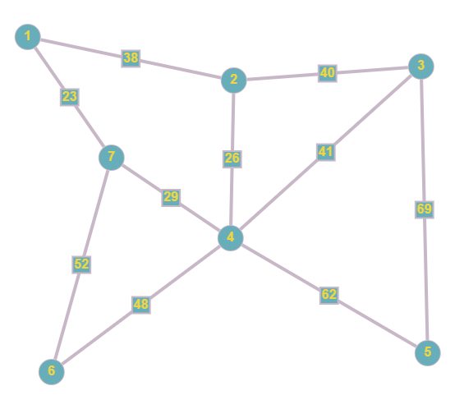

^^graph to show different gyms in the area and the miles between some of the gyms.

# References

Isaac Computer Science. (n.d.). *Isaac Computer Science*. [online]

Available at: https://isaaccomputerscience.org/concepts/prog_cwk_analysis_aqa?examBoard=all&stage=all.

‌